Prakriti Ojha

********************************Section 1***********************************

Sample data to be loaded in Hive Tables
salesman.csv
5001,James Hoog,New York,0.15
5002,Nail Knite,Paris,0.13
5005,Pit Alex,London,0.11
5006,Mc Lyon,Paris,0.14
5003,Lauson, Hen,0.12
5007,Paul Adam,Rome,0.13

customer.csv
3002,Nick Rimando,New York,100,5001
3005,Graham Zusi,California,200,5002
3001,Brad Guzan,London,,5005
3004,Fabian Johns,Paris,300,5006
3007,Brad Davis,New York,200,5001
3009,Geoff Camero,Berlin,100,5003
3008,Julian Green,London,300,5002
3003,Jozy Altidor,Moscow,200,5007

orders.csv
70001,150.5,2012-10-05,3005,5002
70009,270.65,2012-09-10,3001,5005
70002,65.26,2012-10-05,3002,5001
70004,110.5,2012-08-17,3009,5003
70007,948.5,2012-09-10,3005,5002
70005,2400.6,2012-07-27,3007,5001
70008,5760,2012-09-10,3002,5001
70010,1983.43,2012-10-10,3004,5006
70003,2480.4,2012-10-10,3009,5003
70012,250.45,2012-06-27,3008,5002
70011,75.29,2012-08-17,3003,5007
70013,3045.6,2012-04-25,3002,5001

Hive Tables Metadata
salesman
salesman_id int,
name string,
city string,
commission double

customer
customer_id int,
cust_name string,
city string,
grade int,
salesman_id int

orders
ord_no int,
purch_amt double,
ord_date date,
customer_id int,
salesman_id int

Create a database named hive_test and create three tables
salesman
customer
orders
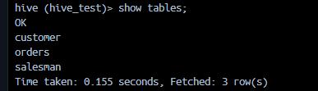

Create above tables with the help of given data and metadata.
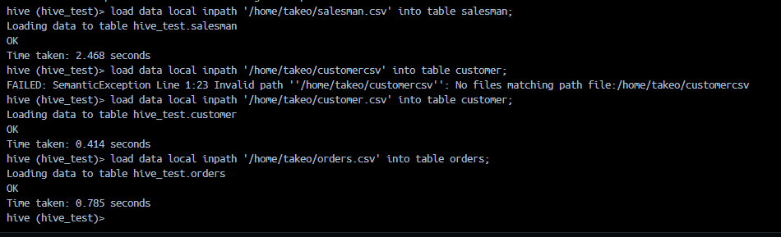
*************************Write SQL For Followings*************************
- Write a SQL statement to prepare a list with salesman name, customer name and their cities for the salesmen and customer who belongs to the same city.
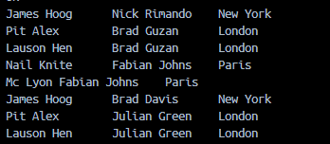

- Write a SQL statement to know which salesman are working for which customer.
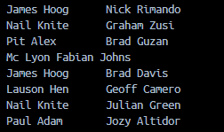

- Write a SQL statement to make a list with order no, purchase amount, customer name and their cities for those orders which order amount between 500 and 2000.
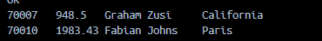

- Write a SQL statement to find the list of customers who appointed a salesman for their jobs who gets a commission from the company is more than 12%.

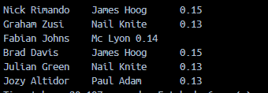
- Write a SQL statement to find the list of customers who appointed a salesman for their jobs who does not live in the same city where their customer lives, and gets a commission above 12% .
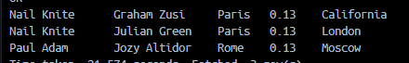
Please submit sql’s for above five questions as your assignment answers.

********************************Section 2***********************************

1. Please complete the below create table commands on complex data and create the table in hive.

Replace ? with appropriate delimiter according to the given data in below create table sql

salesdetail_complex (Product_ID INT,productdetails map<String,String>,Order_Priority VARCHAR(4),merchantType CHAR(4),Sale_Amount DOUBLE,Order_Quantity BIGINT,Discount FLOAT,Salaryhike TINYINT,companyprofit SMALLINT,
financeDeficit DECIMAL(8,2),indian BOOLEAN,saledate array<date>,saleyear array<int>,selleramountfile array<DOUBLE>,orderQuantityfile array<BIGINT>,costlist map<int,int>,strutureType struct<city:string,state:string,pin:bigint>,systemdatetime array<String>) ROW FORMAT DELIMITED FIELDS TERMINATED BY ',' collection items terminated by '$' map keys terminated by '#';

And load below sample data in above table

1,Cam1eras#Cameras$Cameras#Cameras,Medium,Seller,750000,5000000,1500.24,100,1000,1500.659744,TRUE,2012-12-21$2013-12-26,2012$1998,750700.00$850000.01,500000065$500056458,401#901$1200#5410,ap$mp$500001,2019-12-21$2020-12-26 12:00
2,Cam`eras#Nikon$DLR#SmileDetector,Not Specified,Dealer,750001,5000561,1501.24,101,1001,1501.659744,FALSE,2012-12-22$2012-12-27,2012$1999,750001.00$750000.02,500056187$500056458,,ap$mp$500002,2019-12-21$2020-12-26 12:01
3,,High,Seller,750002,5000562,1502.24,105,1002,1502.659744,FALSE,2012-12-23$2012-12-28,2012$2000,750002.00$780000.03,500056245$500056458,400#902$1200#5413,ap$mp$500003,2019-12-21$2020-12-26 12:02
4,Accessories#PentaLite$TV Accessories#Wall Mount,Critical,Dealer,750003,5000563,1503.24,106,1003,1503.659744,FALSE,2012-12-24$2012-12-29,2012$2001,750003.00$790000.04,500056345$500056458,400#903$1200#5414,ap$mp$500004,2019-12-21$2020-12-26 12:03
5,Camera1s#Timbre$Video#Lens Kit,Low,Dealer,750004,5000564,1504.24,108,1004,1504.659744,FALSE,2012-12-25$2012-12-30,2012$2002,750004.00$800000.05,500056458$500056458,400#904$1200#5415,ap$mp$500005,2019-12-21$2020-12-26 12:04

2. Write a sql to get the only 2 records from salesdetail_complex
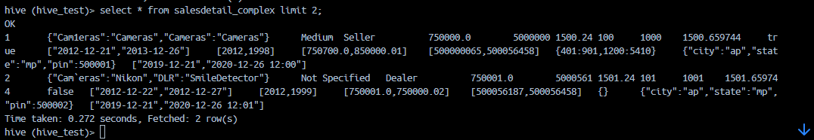

3. Create a non partitioned table named as non_part on below data.
Table metadata for non partitioned table:

Table columns
dateid smallint ,
caldate date ,
day string ,
week smallint ,
month string ,
qtr string ,
year smallint ,
holiday boolean

Sample data from above table.

1827|2008-01-01|WE|1|JAN|1|2008|TRUE
1828|2008-01-02|TH|1|JAN|1|2008|FALSE
1829|2008-01-03|FR|1|JAN|1|2008|FALSE
1830|2008-01-04|SA|2|JAN|1|2008|FALSE
1831|2008-01-05|SU|2|JAN|1|2008|FALSE
1832|2008-01-06|MO|2|JAN|1|2008|FALSE
1833|2008-01-07|TU|2|JAN|1|2008|FALSE
1834|2008-01-08|WE|2|JAN|1|2008|FALSE
1835|2008-01-09|TH|2|JAN|1|2008|FALSE
1836|2008-01-10|FR|2|JAN|1|2008|FALSE
1837|2008-01-11|SA|3|JAN|1|2008|FALSE
1838|2008-01-12|SU|3|JAN|1|2008|FALSE
1839|2008-01-13|MO|3|JAN|1|2008|FALSE
1840|2008-01-14|TU|3|JAN|1|2008|FALSE
1841|2008-01-15|WE|3|JAN|1|2008|FALSE
1842|2008-01-16|TH|3|JAN|1|2008|FALSE
1843|2008-01-17|FR|3|JAN|1|2008|FALSE
1844|2008-01-18|SA|4|JAN|1|2008|FALSE
1845|2008-01-19|SU|4|JAN|1|2008|FALSE
1846|2008-01-20|MO|4|JAN|1|2008|FALSE
1847|2008-01-21|TU|4|JAN|1|2008|FALSE
1848|2008-01-22|WE|4|JAN|1|2008|FALSE
1849|2008-01-23|TH|4|JAN|1|2008|FALSE
1850|2008-01-24|FR|4|JAN|1|2008|FALSE
1851|2008-01-25|SA|5|JAN|1|2008|FALSE
1852|2008-01-26|SU|5|JAN|1|2008|FALSE

4. Now create a partitioned table on column caldate named as date_part from non partitioned table created above

Partitioned table metadata

Table Columns
dateid smallint,
day string ,
week smallint ,
month string ,
qtr string ,
year smallint ,
holiday boolean

Partition column

caldate
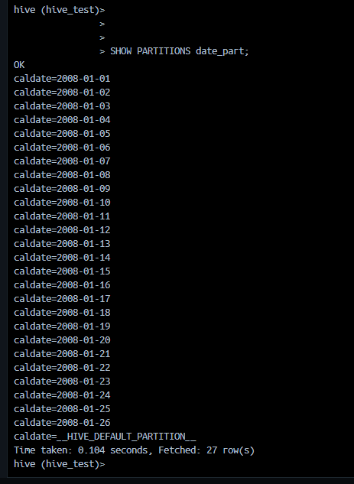

5. Now create a partitioned and bucketed table on above table

Table Columns
dateid smallint,
week smallint ,
month string ,
qtr string ,
year smallint ,
holiday boolean

Partition column

caldate

Bucket column

dateid

